23rd LUCRID WEBINAR ADDRESSES THE PLACE OF GENDER IN QUALITY EDUCATION
The 23rd series of the Landmark University Centre for Research Innovations and Discoveries (LUCRID) webinar held on Wednesday 6th July, 2022 has addressed the place of gender in quality education and governance. The webinar organized by the Department of Sociology in collaboration with Landmark University SDG 5 themed “Gender in Good Governance: Equity and Representation in Diverse World”, discussed the misogyny against women in the society and proffered solutions to curbing such disparity.
Professor Premalatha Karupiah of the School of Social Sciences, Universiti Sains Malaysia, presenting on the topic “Understanding Everyday Misogyny” defined it as an ideology which reduces women to objects that can be manipulated by men. Professor Karupiah noted that misogyny can be in form of violence against women, verbal derogatory remarks, stalking, cyber-stalking and objectification. According to her, misogyny could also be hatred or dislike towards women for example prejudice against women, often explained as a ‘punishment’ for transgressing traditional notion of femininity and so on.
Professor Premalatha Karupiah who expatiates on subtle language misogyny in media, online and day to day communications called on parents, guardians, teachers and handlers to desist from misogyny related jokes, speeches, comparison and examples that could downgrade the position of women in the society.
The Vice-Chancellor, Professor Charity Aremu while giving her remarks stated that the LUCRID webinar series is to situate Landmark University standing in the global space, “to drive information sources and ensure we are on track with the expectations of global standards. We are also maximizing hybrid linkage with the global stage since we are intentional in attracting world class facilitators”. Speaking to the theme of the webinar, Professor Aremu noted that Landmark has always been on the edge of equal representation irrespective of the gender and that to achieve poverty reduction, gender equality must be considered. According to the Vice-Chancellor, considering gender equality in this context is not about unhealthy competition rather it is aimed at breaking the barriers. Professor Aremu incited that the webinar is all inclusive hence the essence of engaging Faculty, Staff and Students most importantly in training the students for global world of works.
In her remarks, the Registrar Miss Adefunke Fola Oyinloye represented by the Head Corporate and Public Affairs, Mr. Olugbenga Olajide noted that the University being globally ranked won’t rest on her oars to continue to ensure excellence in the areas of teaching, research and community development hence the reason for the LUCRID webinar series.
Landmark SDG 5 team lead, Dr. Olushola Akanmode while welcoming participants appreciated the management ably led by the Vice-Chancellor, Professor Charity Aremu for supporting the webinar being SDG 5 maiden outing. She added that the webinar is aimed at reducing any form of discrimination against women in public and private sectors, eradicating harmful practices against women in the society and enhancing continuous participation of women in global developments.
The webinar featured session of questions and answers from over a hundred participants who attended physically and online (from Kogi State, Ogun State, United Kingdom and Malaysia), appreciating Landmark University for her spectacular outing.

The Vice-Chancellor, Professor Charity Aremu at the webinar.

HCPA Mr. Olugbenga Olajide representing the Registrar at the 23rd LUCRID webinar

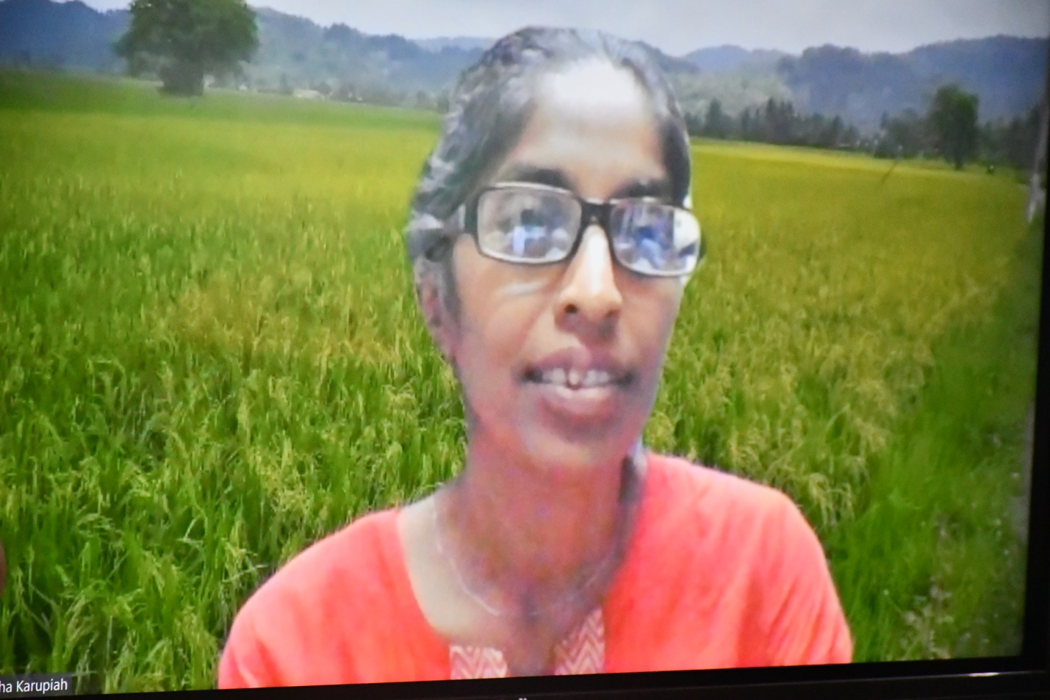
Professor Karupiah during her presentation at the 23rd LUCRID webinar.
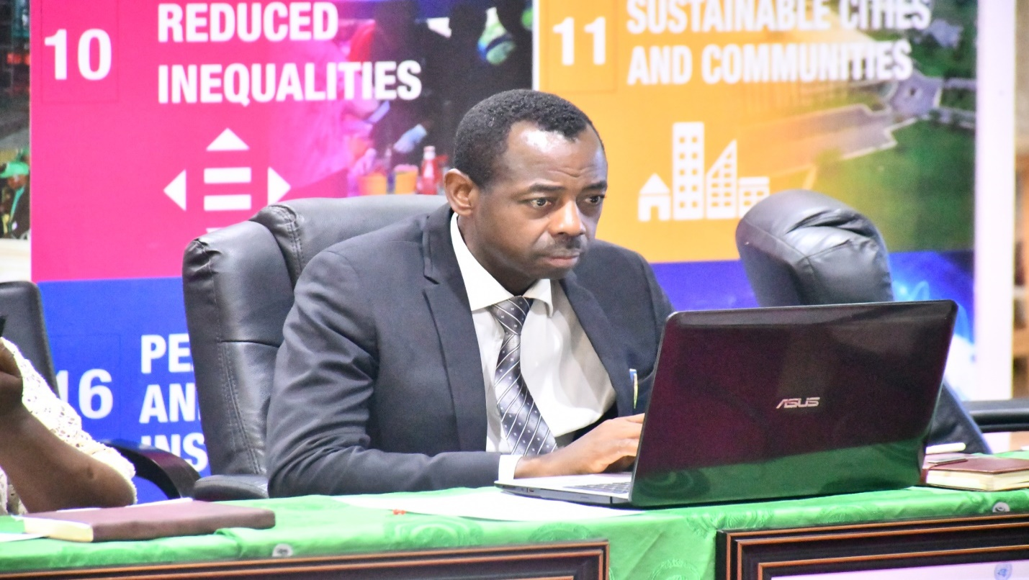
DCBS, Dr. Ben Caleb Egbeide at the 23rd LUCRID webinar

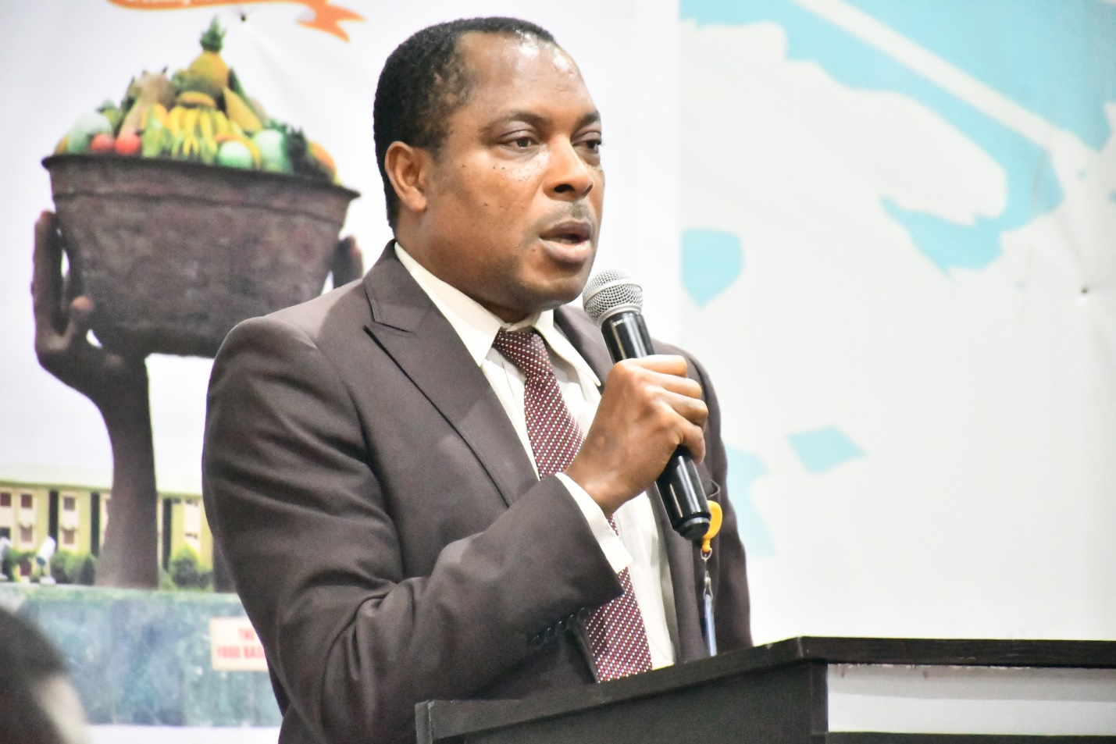
HOD Sociology, Dr. Arizukwu Ogadinma commenting on the topic at the webinar.

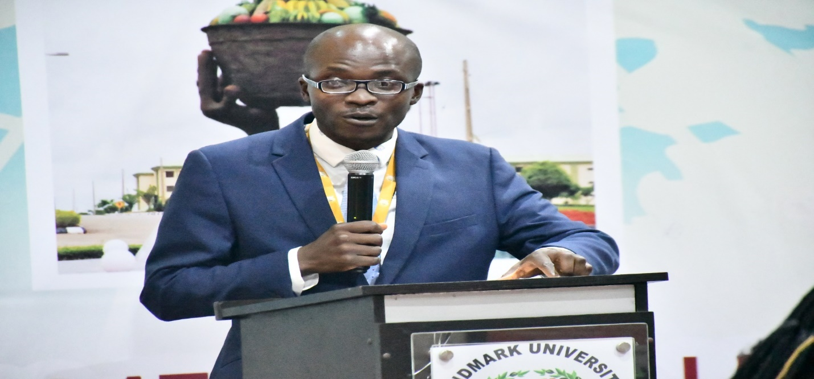
DLUCRID, Dr. A. Adediran giving the prologue of the webinar
SDG 5 Team Lead, Dr. Olushola Akanmode giving her welcome remarks at the 23rd LUCRID webinar

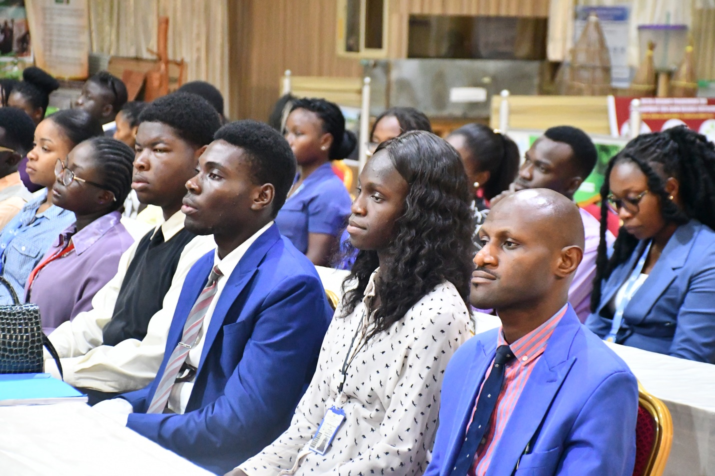
Cross Session of Participants

The Vice-Chancellor in a group photograph with Faculty and Staff after the 23rd webinar

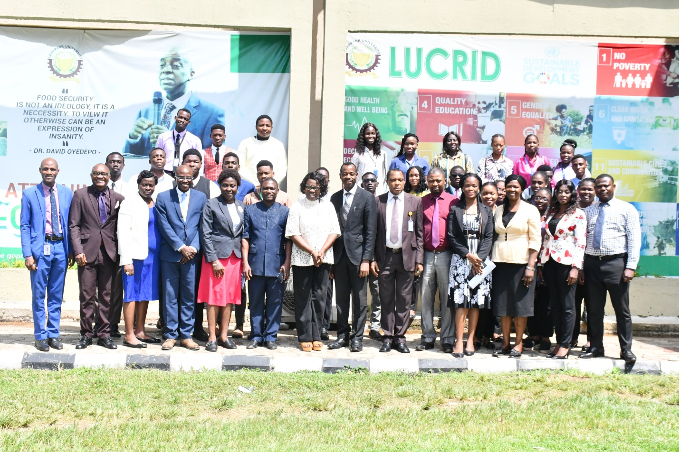
Group Photograph of 23rd LUCRID Webinar

